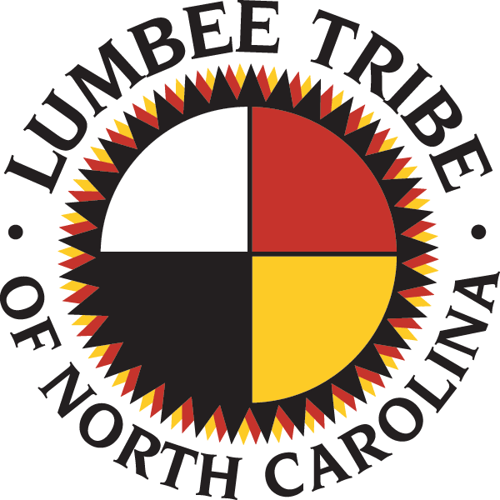
North Carolina Lumbee Tribe Art Competition
Name________________________________________________________________________________
Address___________________________________________________________________________________________________________________________________________________________________
Phone Number______________________________Cell Phone Number___________________________
Email________________________________________________________________________________
Age__________________________Grade___________________________________________________
School________________________________________________________________________________
Parent/Guardian_______________________________________________________________________
Phone Number______________________________Cell Phone Number___________________________
Email________________________________________________________________________________
Name of title or theme – “Missing and Murdered Indigenous Women”
Level 1 – Grades – 5 and 6
Level 2 – Grades – 7 and 8
Level 3 – Grades – 9-12
Select the grade level you are in – Level 1____ Level 2 _____ Level 3____
Awards for each grade level:
1st Place - $50.00 2nd Place - $30.00 3rd Place – $20.00
The overall winner will receive $100.00.

Criteria: The art piece will be judged on originality and content.
Artwork dimensions: 11” X 14”
Do not write your name on your art piece.
Titles and any other written information must have correct spelling, grammar, and punctuation.
All applicants must be an active member of the Lumbee Tribe and must submit a copy of their membership. The Tribal Office is open to update membership.

Judges will be selected from the professional field of educators and artists. The art piece must be original and not have been published or plagiarized. Money awarded to the applicant must be resubmitted to the Lumbee Tribe if the art piece is not original and/or has been published or plagiarized. Deadline to submit___October 15, 2021__

Submit application to:
Lumbee Tribe of North Carolina
Education Committee: Belinda Brewer
6984 N.C. Hwy 711 West
Pembroke, N.C. 28360
Contact Number: 910-521-7861

*Please research on internet to learn more about the theme—Missing and Murdered Indigenous Women.

Parent Consent

The creative art piece my child, _________________________, submitted to the Lumbee Tribe of N.C. for the art competition is his/her original work, and it has not been published or plagiarized. I do hereby grant permission for the Lumbee Tribe of N.C. to disseminate my child’s creative art.

Parent/Guardian__________________________ Date_______________
Print Name

Parent/Guardian__________________________
Signature

